Gateways are part of life. We move through gates along life’s road every day, all day. We choose when and where we turn. Most of these choices have little consequence. Some have monumental consequences. In the greatest sermon that Jesus ever preached he stated that two of these mammoth choices come to us in the form of gates.
Jesus invites you to “Enter through the narrow gate; for the gate is wide and the way is broad that leads to destruction, and there are many who enter through it. “For the gate is small and the way is narrow that leads to life, and there are few who find it.” (Matthew 7:13-14)
You had no choice about the gate you first entered. That gate, our human birth, set our path along a wide path with many travelers. But that path leads to destruction. The Bible teaches us that we are born with a sin nature and we sin because of that nature. Sadly “the wages of sin is death.” (Romans 6:23a)

We set before you another choice. We ask you to choose life. The remainder of the above verse reads: “but the free gift of God is eternal life in Christ Jesus our Lord." (Romans 6:23b) You might wonder why the gate is “small and the way narrow”? The gate is small because eternal life can only be gained through:
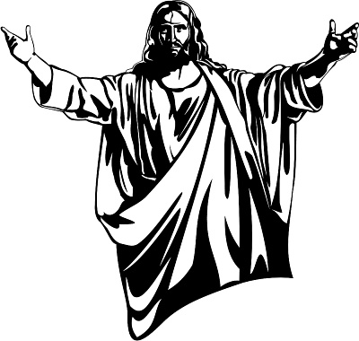

a. One Person. Jesus said that he was the door (John 10:7) and that he was the one and only way to God the Father ("Jesus said to him, “I am the way, and the truth, and the life; no one comes to the Father but through Me." (John 14:6)) The goal of choosing eternal life is a living relationship with God.

b. One Way. Salvation is a gift from God but it can only be received by faith ("For by grace you have been saved through faith; and that not of yourselves, it is the gift of God."(Ephesians 2:8, NASB95) Faith is trusting – trusting only and completely in Jesus Christ as the one who surrendered his life for your sin on the Cross taking your place. Faith is empty hands extended to receive God’s gift. (For God so loved the world, that He gave His only begotten Son, that whoever believes in Him shall not perish, but have eternal life. (John 3:16)
c. One Step. To enter the narrow gate requires one step – surrender. Surrender in war means giving up. Surrendering to Christ means turning away from your present life to following Christ. The Bible calls this repentance. Jesus said that to be a Christian (a follower of Christ) ". . . he must deny himself, and take up his cross and follow Me." (Matthew 16:24)
That is why the gate and the way is narrow. We pray that the grace of God will show you that the joys and rewards of eternal life are worth it. Jesus said, "I came that they may have life, and have it abundantly."(John 10:10)
It would give us the greatest privilege to help you take that step to know God through Christ Jesus. You would be welcome to contact us at 780-724-4194 for further assistance.
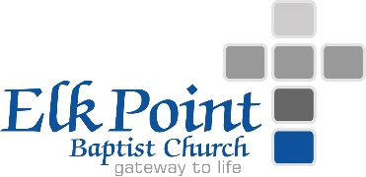
mainoffice@elkpointbaptistchurch.com

