PASTOR'S BIBLE STUDY RECOMMENDATIONS

Admittedly I am saddened and burdened by the plethora of so-called Bible studies that are anemic and at worst unbiblical. To create a topic and then find verses to support it in the bible lacks integrity and the Spirit's blessing. We need use study aids where the author draws the message from the Bible, first, and then applies it. I have started a list of studies that I believe do that. I will add as more become available. If you know of one that you think should make the list, let me know and I will try to review it. – Pastor Jim

Current date: Thursday, December 01, 2016

A. | 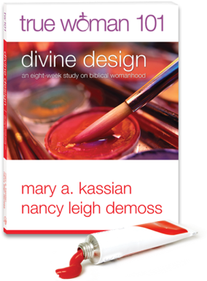 | This is an eight-week study with DVD on biblical womanhood. Each week includes 5 individual lessons leading to a group time. The authors are developing a systematic follow-up with True Woman 102 (not out yet).  http://www.truewoman101.com/
B. | 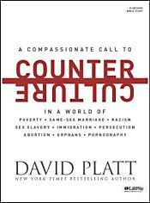 | David Platt believes that the truths of the gospel should compel us to a contrite, compassionate, and courageous personal response to social issues in the culture. This is a 6-session study with videos.  http://www.lifeway.com/n/Product-Family/Counter-Culture
C. | 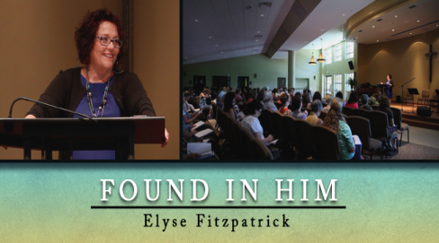 | Elyse Fitzpatrick explores the wonder of the incarnation and the glory of our union with Christ, offering us a sure path to ultimate acceptance and true belonging through the power of the gospel. This is a 10 – 20 minute video program with material.  http://www.ibcd.org/utility/found-in-him/
D. | 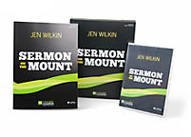 | Helps group members learn what it means to be a citizen of the kingdom of Heaven according to Jesus' Sermon on the Mount through a 9-week study led by Jen Wilkin. What does it mean to be a citizen of the kingdom of Heaven?  http://www.lifeway.com/Product/the-sermon-on-the-mount-leader-kit-P005644877
E. | 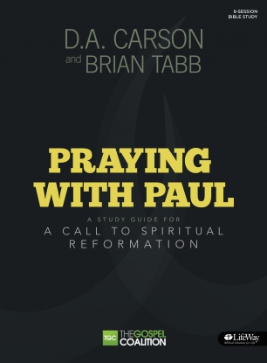 | Praying with Paul leads group members into the Epistles to see what Paul taught in his “school of prayer.” In 8 sessions groups and group members will be exposed to priorities of prayer, a God-centered framework for prayer, and practices for a more dynamic and meaningful prayer life. Kit includes a small-group member study guide and 2 DVDs with a promotional video and eight 20-minute teaching sessions led by D. A. Carson.  http://www.thegospelcoalition.org/publications/entry/praying-with-paul
F. | 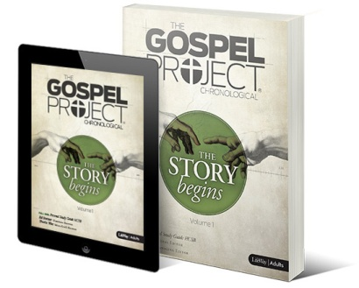 | The Gospel Project® is a chronological, Christ-centered Bible study for Adults that examines how all Scripture gives testimony to Jesus Christ. Over the course of three years, participants will journey from Genesis to Revelation and discover how God’s plan of redemption unfolds throughout Scripture and still today, compelling them to join the mission of God.  This is coming out in the Fall of 2015  http://www.gospelproject.com/
G. |  | The Bible commands us to rejoice in the Lord always. But what if that is not our experience? In this course, Dr. John Piper teaches the importance of having proper affections for God and shares strategies for how we can fight to have them.  This is an online course provided by Ligonier Ministries and is free.  https://connect.ligonier.org/school/catalog/course/when-i-dont-desire-god/
H. |  | Look at the Book is a new online method of teaching the Bible. It’s an ongoing series of 8–12 minute videos in which the camera is on the text, not the teacher. You will hear John Piper’s voice and watch his pen underline, circle, make connections, and scribble notes — all to help you learn to read God’s word for yourself. His goal is to help you not only see what he sees, but where he sees it and how he found it. Each lesson comes with 3-4 study questions to discuss. Online and free.  http://www.desiringgod.org/labs/all
I. | 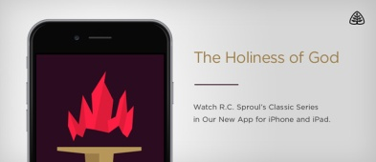 | R.C. Sproul’s classic video series The Holiness of God is available now in the App Store as a free interactive course from Ligonier Connect for iPhone or iPad.  Thousands of people testify to a transforming encounter with God after watching this series or reading the bestselling book. And now you can study The Holiness of God as you watch videos, take interactive quizzes, and more.  Download The Holiness of God for free from the App Store, create your Ligonier Connect account.
J. | 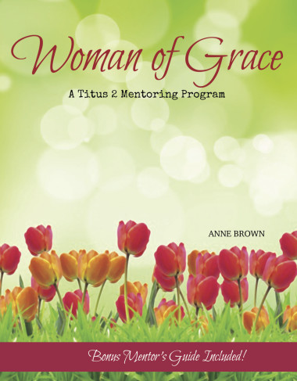 | Woman of Grace is a ready-made curriculum to help prepare the next generation of wives and mothers serve their families well, radiate Christian character, and bring glory to the name of Jesus.  Cross to Crown Ministries http://ht.ly/Mmec4
K. | 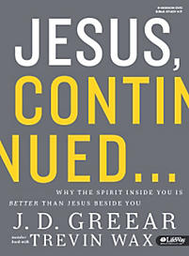 | Jesus, Continued - Bible Study Kit  Why The Spirit inside You Is Better Than Jesus Beside You  Why do so many of us think of Christianity as a lifestyle to which we conform, rather than a God with whom we commune? Jesus gave His disciples the audacious promise that it was to their advantage that He go back to heaven because the Holy Spirit could then come to live inside of them. How many of us consider our connection to the Holy Spirit so strong and so real that we would call his presence in us better than Jesus beside us?  http://www.lifeway.com/Product/jesus-continued-bible-study-kit-P005748700
L. | 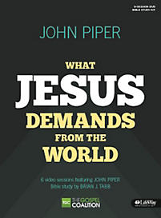 | What Jesus Demands from the World - Bible Study Kit  includes a small-group Bible Study Book and one DVD with a promotional video and six 10-minute teaching sessions featuring author John Piper.  This study serves as an accessible introduction for thoughtful inquirers and new believers, as well as a refreshing reminder for more mature believers of God's plan for His Son's glory and our good.  http://www.lifeway.com/Product/what-jesus-demands-from-the-world-bible-study-kit-P005644091?intcmp=jesusdemands-MTX-Text-LeaderKit-20150331
M. | 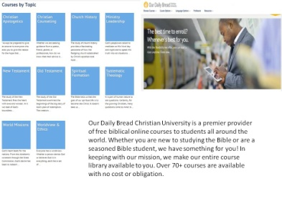 | Our Daily Bread Christian University is a premier provider of free biblical online courses to students all around the world. Whether you are new to studying the Bible or are a seasoned Bible student, we have something for you! In keeping with our mission, we make our entire course library available to you. Over 70+ courses are available with no cost or obligation.  For Example:  NT504 New Testament Survey: The Gospels/Life of Christ  Lecturer: Dr. Terry Hulbert  In this course, students complete a chronological and synthetic study of the Gospels’ accounts of Christ’s birth, life, death, resurrection, and ascension. The course focuses on the time, place, circumstances, and people involved in the events of our Lord’s ministry. From the incarnation to the ascension, students will grasp a fuller understanding of Christ’s words and works in light of Old Testament prophecy and cultural context.  NT505 The Parables of Jesus  Lecturer: Dr. Craig Blomberg  Most readers empathize with the disciples’ request that Jesus explain His parables. This course surveys various methods of interpreting Jesus’ parables and offers an eclectic model that draws upon the best insights of each. Blomberg’s semi-allegorical model is then applied to each of the major narrative parables in the Gospels. Blomberg examines differences among parallel accounts and suggests plausible reasons for the variations. Students are encouraged to apply the conclusions about the theology and significance of Jesus’ parables to their lives and ministries.  http://christianuniversity.org/free-courses/
N. | 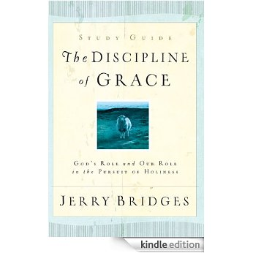  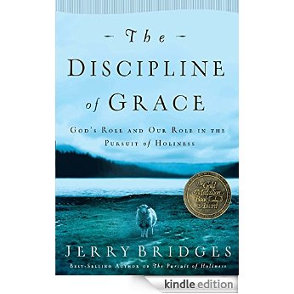 | Discipline of Grace  Jerry Bridges  Bible teacher Bridges here invites Christian believers who are pursuing holiness to pause for a moment to consider the role of God's grace in making such pursuit possible. Bridges urges the discernment of grace and the subsequent practice of the disciplines of commitment, conviction, choices, watching, and adversity.  Book: http://www.amazon.ca/The-Discipline-Of-Grace-Holiness/dp/1576839893  Study Guide: http://www.amazon.ca/The-Discipline-Grace-Study-Guide/dp/1576839907
O | 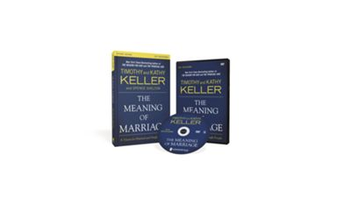 | The Meaning of Marriage Study Guide with DVD  In this six-session video Bible study, Timothy Keller, along with Kathy, his wife of forty years, share a profound portrait of marriage from the pages of Scripture that is refreshingly frank and unsentimental, yet hopeful and beautiful.  http://biblegateway.christianbook.com/the-meaning-marriage-study-guide-with/9780310874911/pd/874911  Watch the first session free on YouTube: https://youtu.be/qMR8gRRMXok?list=PLF50A7F0A0EAB162A
P | 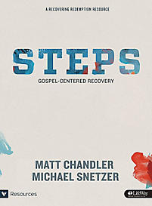 | Steps - Bible Study Book  Steps: Gospel-Centered Recovery - Bible Study Book includes small-group experiences and discussion guides for 13 sessions, individual study, applicable Scripture, and personal assessments.  This 13-session discipleship program takes people to the root of sin and suffering in order to embrace the freedom found only in Christ's redemption. Potentially life-changing experiences are brought about by in-depth Bible study, thorough personal assessments, insightful teaching videos, and honest interactions with a group leader and mentor.  http://www.lifeway.com/Product/steps-bible-study-book-P005644097
Q | 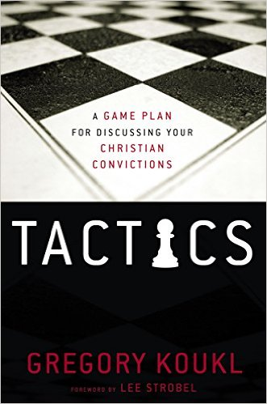 | In the Tactics Study Guide with DVD, apologist and radio host Gregory Koukl demonstrates how to get in the driver’s seat in discussions about faith, keeping any conversation moving with thoughtful, artful tact. Readers will learn how to maneuver comfortably and graciously through the minefields, stop challengers in their tracks, turn the tables and—most importantly—get people thinking about Jesus with conversations that look more like diplomacy than D-Day.  Drawing on extensive experience defending Christianity in the public square, Koukl demonstrates how to:  - Initiate conversations effortlessly  - Present the truth clearly, cleverly, and persuasively  - Graciously and effectively expose faulty thinking  - Skillfully manage the details of dialogue  - Maintain an engaging, disarming style even under attack  The Tactics Study Guide with DVD provides a game plan for communicating the compelling truth about Christianity with confidence and grace.  http://www.christianbook.com/tactics-study-guide-with/9780310531944/pd/531944?event=ESRCG
R | 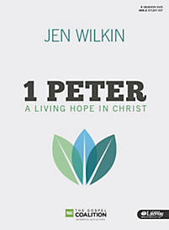 | Our inheritance through Christ is imperishable, undefiled, and unfading. In 1 Peter, a man of faith and flaws and eyewitness to the life of Christ challenges us to look beyond our current circumstances to a future inheritance. He shares his concerns on big picture issues for the early church, describes believers’ true identity in Christ, and ultimately helps readers discover what it means to experience the Living Hope they have in Christ. Key themes of humility, submission, and identity in Christ guide the study of 1 Peter as participants are challenged to read the book in its entirety each week. (9 sessions)  Kit Includes:  1 Bible Study Book  Leader Guide  2 DVDs with eight 30-minute teaching sessions led by author Jen Wilkin  Promotional video  http://www.lifeway.com/Product/1-peter-a-living-hope-in-christ-leader-kit-P005772640
S | 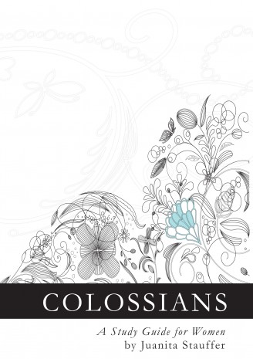 | The Apostle Paul's letter to the Christian church in Colossae was written almost two thousand years ago, yet its message is as timeless and relevant as ever. Designed to assist Christian women in their discipleship to Jesus Christ, "Colossians: A Study Guide for Women" is a nine-week journey through this ancient text. Readers using Juanita Stauffer's guide for either personal study or for group discussion will gain insight into what it is to be "in Christ" through the Gospel.  Originally prepared to accompany a Calvary Grace Church women's Bible study, this study guide is available to anyone who is interested, in two versions:  1. A 140-page paperback book. You can order it from Amazon here:  Colossians: A Study Guide for Women (paperback--link to Amazon.ca)  2. A free PDF-format e-book download, in US letter size, to make it easy to print. You can download the PDF here:  Colossians: A Study Guide for Women (free PDF download)
T |  | See How God Created Us To Function According To His Perfect Design As Men & Women  A 9-Session Study for Small Groups  God created us to function according to His perfect design, and for all of human history, our world has been male and female. But our ever-changing culture faces challenges due to sin. More than ever the church needs to be a safe refuge for the gender confused, the sexually broken, the single, the married, and the divorced.  In this study, Matt Chandler gives evidence that God’s plan for man and woman is the ultimate design. And life lived within this beautiful and unchanging design is part of His greater purpose for humanity.  http://www.lifeway.com/n/Product-Family/A-Beautiful-Design?CID=LAR-ABD-TGC-20160401
U | 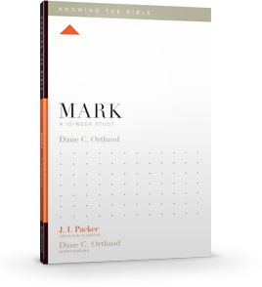 | The Knowing the Bible series is a new line of Bible studies designed to help Bible readers better understand and apply God’s Word.  Each study covers one book of the Bible over 12 weeks, making practical applications and connections between the passage and the rest of Scripture.  The series is edited by theologian J. I. Packer, and includes contributions from an array of influential pastors and church leaders. Perfect for both small groups and individuals, these gospel-centered studies will help you see and cherish the message of God’s grace on each and every page of the Bible.  Each study includes:  Reflection Questions designed to help you engage the text at a deeper level  - Gospel Glimpses highlighting the gospel of grace throughout the book  - Whole-Bible Connections showing how a passage connects to the Bible’s overarching story of redemption culminating in Christ  - Theological Soundings identifying how historic orthodox doctrines are taught or reinforced throughout Scripture  There are currently 41 Books of the Bible completed in this series. Excellent Bible Study resource. Books are $8.99 US and are available in paperback or e-book format.  http://knowingthebibleseries.org/
V | 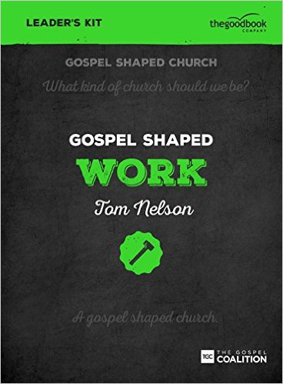 | Gospel Shaped Work - DVD Leader's Kit  Boxed Leader Kit for an eight-week curriculum exploring how to put the gospel at the heart of everything we do at work  Also:  - Gospel Shaped Work Leader's Guide  Gospel Shaped Work Handbook  http://www.christianbook.com/gospel-shaped-work-leaders-kit/9781910307571/pd/307574?event=ESRCG
w | 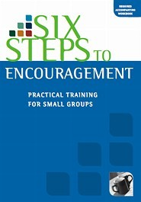 | God has given every Christian an enormous privilege and gift: the power to speak his life-changing word into the lives of other people. There's no reason at all for there to be 'passengers' in a church: every Christian can change the lives of those around them through knowing and telling the message of God's grace, whether in front of a group, in a hand-written note, in a one-to-one conversation over morning tea, or in a thousand other ways. Every Christian can be a channel of encouragement.  In Six Steps to Encouragement you'll learn the why and how of personal encouragement. Through video input, Bible study, practical examples, discussions and hands-on exercises, you'll discover how to bring life, hope and strength to those around you by bringing the powerful word of God to them. You'll also work through practical case studies such as welcoming newcomers, listening, rebuking, and dealing with suffering.  http://www.matthiasmedia.com/six-steps-to-encouragement-dvd
X | 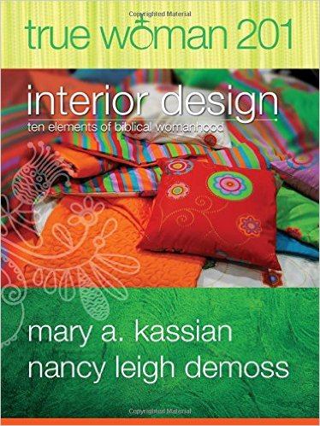 | True Woman 201: Interior Design - Ten Elements of Biblical Womanhood (True Woman)  Having a talented designer come in and create a new look for a home or restaurant is a popular topic of TV reality shows. These renovation shows are a great illustration for the object of this study. The Lord is the ultimate Designer. And He has a divine design for womanhood. He wants to come in and do a radical renovation of your heart. He wants to change you from the inside out. If you let Him, He'll give you an extreme makeover . . . a brand new interior design.  In 201, we'll turn to the New Testament, to the book of Titus, to focus on some important elements of redeemed womanhood. Each week of this True Woman 201 study examines one of the ten "design elements" of womanhood drawn from the Titus 2. The weeks are each divided into five lessons leading to a group time of sharing and digging deeper into God's Word  https://www.amazon.ca/True-Woman-201-Interior-Womanhood/dp/0802412580/ref=sr_1_1?ie=UTF8&qid=1480207531&sr=8-1&keywords=true+woman+201
Y | 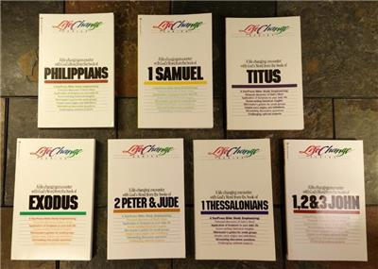 | LifeChange Bible Study Series  Christians have a lifelong goal: to become like Christ. This involves change, and change isn't always easy. But the more you know of God's purposes for you, the more you can experience His joy and participate in His plan. THE LIFECHANGE SERIES of Bible studies on books of the Bible can help you grow in Christlikeness through a life-changing encounter with God's Word.  So far 45 Bible book studies are produced  https://www.christianbook.com/page/bible-studies/bible-study-series/lifechange-series

“Do your best to present yourself to God as one approved, a worker who has no need to be ashamed, rightly handling the word of truth.” (2 Timothy 2:15, ESV)

